# Task 8 - Documentation

As part of Task 5, I implemented the following components using Xampp:

* Implemented login/logout functionality using PHP and MySQL.
* Created two tables: user (user info) and userlog (login/logout tracking).
* Built an admin panel to manage users (add, edit, delete, update status).
* User is revoked after more than 3 failed login attempts.
* Stored session info in the userlog table for each login/logout.
* Added SQL export/download for table creation and user inserts via UI.

# File Organization in Directory (htdocs/cs6314/task5)

|  |  |
| --- | --- |
| File Name | Description |
| db.php | Database connection file used by all PHP scripts. |
| create_tables.php | Creates user and userlog tables in the database and triggers SQL file download. |
| setusers.php | Inserts initial admin and user into the user table and downloads the insert SQL. |
| login_form.php | Login page with a form for user ID and password. Displays error messages on failure. |
| login.php | Handles login logic: verifies credentials, tracks failed attempts, starts session, logs login time. |
| logout.php | Logs the user out, destroys session, updates logout time in userlog. |
| admin.php | Admin dashboard with links to manage users and view login logs. |
| manage_users.php | Displays a list of users with options to add, edit, or delete them. |
| add_user.php | Form to add a new user to the system. |
| edit_user.php | Form to update user details; resets failed attempts when status is set to active. |
| delete_user.php | Deletes a user based on their ID. |
| view_userlog.php | Displays all login/logout history from the userlog table. |
| main.php | Homepage for regular users after login  (final output of Task 3). |
| sql folder | Contains create_user_tables.sql and set_initial_users.sql |

# create_tables.php

Tables are created by executing the create_tables.php in the browser

Which will

* Execute the SQL and create the tables
* Trigger a download of the SQL file (create_user_tables.sql) after execution

# setusers.php

Added Users (admin1 and user2) to the table with status active by executing setusers.php in browser which will

* Insert the two initial users
* Download a .sql file with the insert statements after the success message is shown

# “user” Table Description

|  |  |  |
| --- | --- | --- |
| Column Name | Date Type | Description |
| id | INT (AUTO_INCREMENT) | Unique primary key for each user. |
| userid | VARCHAR(50) | Unique username used for login. |
| password | VARCHAR(255) | Encrypted user password. |
| user_type | ENUM('admin','user') | Specifies the role of the user. |
| user_status | ENUM('active', 'inactive', 'revoked', 'deleted') | Current status of the user account. |
| first_name | VARCHAR(100) | User’s first name. |
| last_name | VARCHAR(100) | User’s last name. |
| email | VARCHAR(100) | User’s email address. |
| failed_attempts | INT | Tracks number of failed login attempts. |
| created_at | DATETIME | Timestamp when the user account was created. |
| updated_at | DATETIME | Timestamp of last update to the user’s record. |

# “userlog” Table Description

|  |  |  |
| --- | --- | --- |
| Column Name | Date Type | Description |
| id | INT (AUTO_INCREMENT) | Unique primary key for each login session. |
| userid | VARCHAR(50) | |  | | --- | | User ID of the person logging in. |  |  | | --- | |  | |
| login_time | DATETIME | Timestamp when the user logged in. |
| logout_time | DATETIME | Timestamp when the user logged out. |
| session_id | |  | | --- | | VARCHAR(50) |  |  | | --- | |  | | PHP session ID associated with the login session. |

# Created the Login Form (login_form.php)

This is the front-end where the user enters their credentials.

# Created the Login Logic (login.php)

This file:

* Checks credentials
* Logs login in userlog
* Revokes account after 3 failed attempts
* Creates session

# Created logout.php

Also added logout button in main.php file above nav bar in <body> tag

# Testing login_form.php

Tried entering the wrong password then you can see “Invalid password. Attempt 1 of 3” on the screen in the next screenshot.

Userlog table is updated.

User not found error when there is no user found in the users table.

When user attempts wrong password for more than 3 times, the users gets revoked.

You can see the user2 is revoked, now to allow him to login admin need to update user2 status to active by using update action.

Update user2 status to active to allow him to login again

Updated user2’s status to active

If a user is in Inactive state or Revoked state he/she cannot login

# For Admin Panel & User Management

I made:

* **admin.php** – main dashboard
* **manage_users.php** – list all users
* **add_user.php** – form to add a user
* **edit_user.php** – form to update a user
* **delete_user.php** – deletes a user
* **view_userlog.php** – shows login/logout activity

All these pages are admin-only and use session-based login protection.

After sucessfull login of admin1

When Manage Users is clicked

When View Login Logs is clicked

Adding a new user (user3)

Here is the updated table with user3 added to it.

Similarly I added user4🡪user and user5🡪admin as told in the document, and here is the final result after addition.

Added a new user with ID 123 to test edit functionality

When edit is clicked (in Actions column from the 6th row), we go to the update form page

We can update all firlds except the UserID (Primary key) and click Update

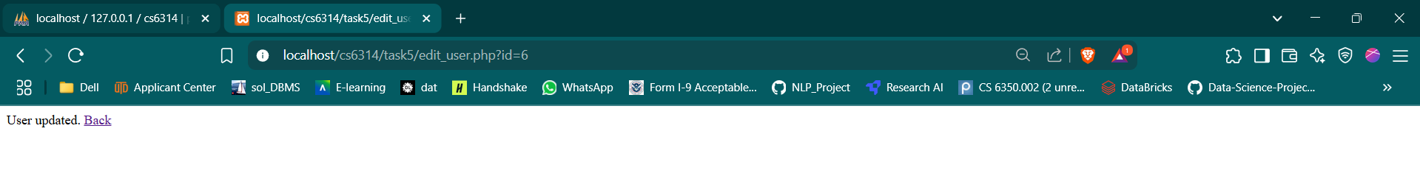

Final table after updating

When Delete is selected from the Actions column, the user gets deeted

When Ok is clicked here, the user gets deleted

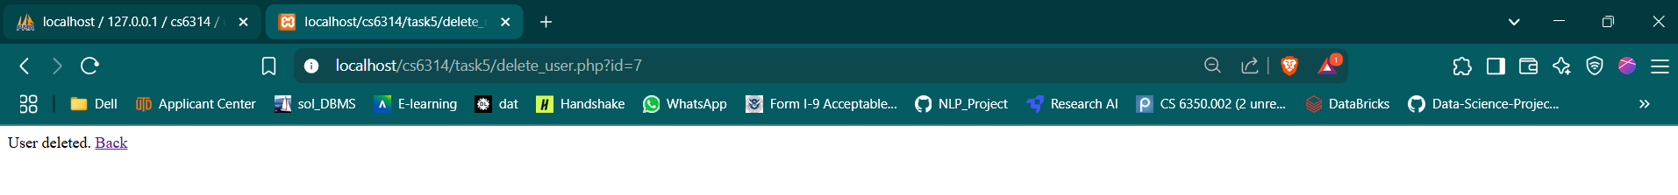

Final table after deletion

Throughout every action the original table in the cs6314 database will also be updated

Also when logout is clicked, we go back to login_form.php

# main.php

When we login as a User then we get redirected to main.php which is final php page made in task3 of Project part 1

Also I Updated the following in main.php

* A session-based access control at the top
* A div to display the logged-in user’s ID
* Provide a logout button

Also I tried logging in as User5 who is admin and you can see the loging logs in both userlogs table and in view_userlog.php page

# Final xampp/htdocs/cs6341/task5 directory

